Roomify
Deployment
Proposed hosting, cost and steps (proposal only, not deployed)
Team Bootcamp2Roomify
Release v1.0.0 (demo mode)
24 October 2026

Status (2026-10-26): approved, configs committed, Neon database created, not yet deployed. Blocked on (1) a payment method on the Fly.io account (fly apps create answers "We need your payment information") and (2) a bucket-scoped AWS key. The judging build runs with AI_DEMO_MODE=true (see step 3).

Recommendation: Vercel + Fly.io + Neon + existing S3
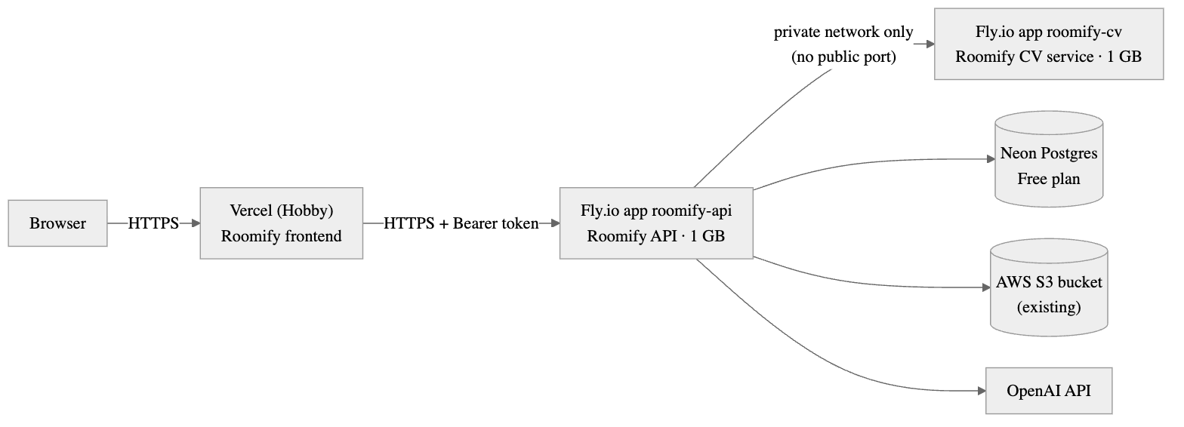
Figure 1. Proposed Roomify deployment: Vercel for the frontend, Fly.io for the API and a private CV service, Neon Postgres, the existing S3 bucket and the OpenAI API.
Why this shape:
- Each service already ships as a container (backend and CV Dockerfiles are pinned and tested), so the hosts only run images: no build-system work.
- The CV service gets no public address. It has no authentication and an image_url input; Fly's private network lets only the backend reach it.
- Long AI calls fit. Image edits can take up to ~2 minutes. Vercel Hobby functions with Fluid compute allow 300 s; the backend's AI timeout is 180 s. The browser never calls the backend directly (the Next bridge does), so no CORS changes are needed.
- Measured memory fits 1 GB machines: CV container 374 MiB after inference, backend 424 MiB after start-up (Docker, 2026-10-24).

Cost (list prices checked 2026-10-24)
Piece | Plan | Monthly
Frontend | Vercel Hobby (personal/non-commercial — fine for judging) | $0
Backend | Fly.io shared-cpu-1x, 1 GB, always on, iad | $6.70
CV service | Fly.io shared-cpu-1x, 1 GB, always on, iad | $6.70
Database | Neon Free (0.5 GB storage, scales to zero after 5 min idle) | $0
Images | Existing AWS S3 bucket (Standard ≈ $0.023/GB-month) | < $0.10
Infrastructure total |  | ≈ $13.40 / month
OpenAI usage | per redesign: plan + concept + suggestions + DIY | Demo mode (pre-generated results) — $0 while AI_DEMO_MODE=true (Evaluation Evidence §2)
Notes: Fly bills per second, so stopping the machines after judging stops the cost. Fly raised its RAM price on 2026-10-01 (1 GB machine $5.70 → $6.70); Frankfurt is $7.73. Neon's first query after idling has a cold start of up to a few seconds. Sources: Fly.io pricing, Vercel function limits, Neon pricing.

Steps (to run after approval)
Prerequisites the owner provides: Fly.io account (fly auth login), Vercel account linked to the GitHub org, Neon account, the existing S3 bucket name/region and an IAM key scoped to that bucket, an OpenAI key.
- Database — neonctl projects create --name roomify --region-id aws-us-east-1, then neonctl connection-string --project-id <id> for host, database, user and password.
- CV service (private) — roomify_cv/fly.toml is committed: no public service, CV_HOST="::" because Fly's private network (roomify-cv.internal) is IPv6-only and the image default 0.0.0.0 is IPv4.
- cd roomify_cv
fly apps create roomify-cv
fly deploy -a roomify-cv
fly ips list -a roomify-cv # must be empty: no public address
- Backend — roomify_backend/fly.toml is committed (1 GB, always on, /api/health check, VISION_SERVICE_BASE_URL=http://roomify-cv.internal:8000, STORAGE_TYPE=s3).
- cd roomify_backend
fly apps create roomify-api
fly secrets set -a roomify-api \
SPRING_DATASOURCE_URL='jdbc:postgresql://<neon-host>/<db>?sslmode=require' DB_USERNAME=<user> DB_PASSWORD=<password> \
JWT_SECRET=$(openssl rand -hex 32) OPENAI_API_KEY=<key> \
S3_BUCKET=<bucket> AWS_REGION=<region> AWS_ACCESS_KEY_ID=<id> AWS_SECRET_ACCESS_KEY=<secret>
fly deploy -a roomify-api
curl https://roomify-api.fly.dev/api/health
- Demo mode: fly.toml sets AI_DEMO_MODE=true, so the plan, visual concept, suggestions and DIY guides come from the bundled demo library (fitted to the user's furniture decisions and budget; the concept is a stock photo for the room type) and every result is marked source: "demo". With AI_DEMO_MODE=false the app calls OpenAI and, because AI_DEMO_FALLBACK defaults to true, still answers from the library if a call fails (401, 429, timeout, invalid output); each fallback is logged as AI demo result used: feature=… case=… reason=…. Neon requires TLS, so the JDBC URL is set whole with sslmode=require (it overrides DB_HOST/DB_PORT/DB_NAME). Long AI calls: Fly's proxy closes a connection after 60 s with no bytes; an image edit can be silent for ~2 minutes, so fly.toml sets http_options.idle_timeout = 600. A Fly community report says this setting may not take effect: the smoke test (step 5) must include a visual concept. If it is cut off, the fix is to make the concept endpoint asynchronous (202 + poll).
- Frontend — Vercel → Add New Project → import Bootcamp2Roomify/roomify_frontend → framework Next.js → environment variable ROOMIFY_API_URL=https://roomify-api.fly.dev → Deploy. The project API bridge sets maxDuration = 300 so AI calls are not cut at Vercel's non-Fluid 10 s default.
- Smoke test — run the live browser suite against the deployment: LIVE_BASE_URL=https://<project>.vercel.app LIVE_AI=1 npx playwright test -c playwright.live.config.ts.
- After judging — fly scale count 0 -a roomify-api -a roomify-cv (stops billing), or fly apps destroy.

Risks
- gpt-4o-mini (default text model) is shut down by OpenAI on 2027-01-14; switch to gpt-6-luna with AI_TEMPERATURE= and AI_REASONING_EFFORT=low before then (config only).
- Vercel Hobby is for non-commercial use; move to Pro ($20/month) for anything beyond judging.
- A public demo can spend the OpenAI budget: set a monthly usage limit in the OpenAI dashboard.

